Part I: Importing and Indexing a Data Set
Importing a CSV file using the appropriate MongoDB import tool
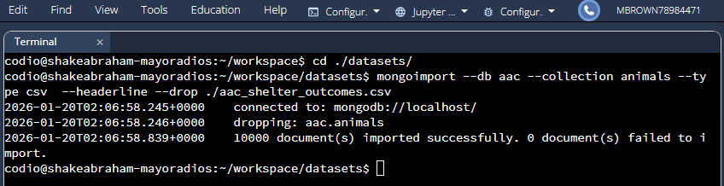

Create a simple index on the key “breed.”
db.animals.createIndex({ breed: 1 })
db.animals.find( { breed: "Border Collie Mix" } ).explain("executionStats")
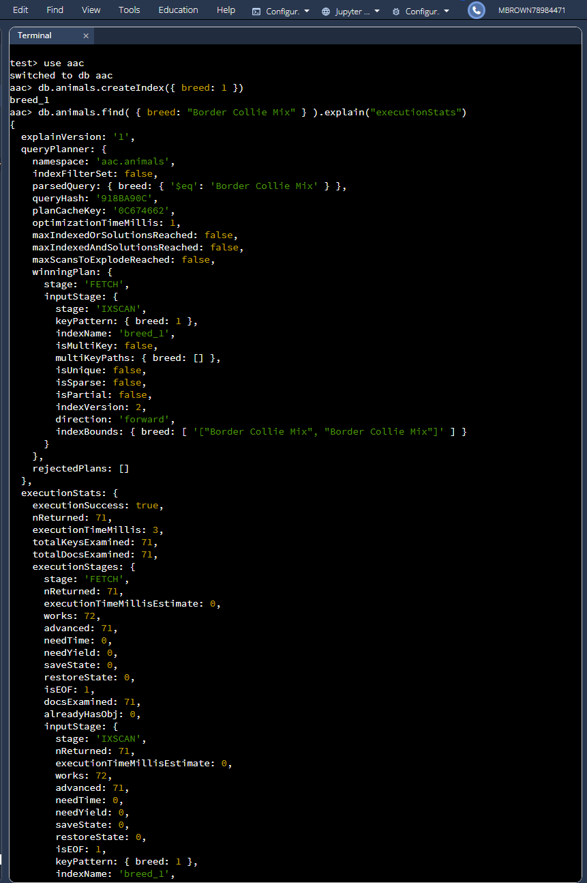
Create a compound index
db.animals.createIndex( { breed: 1, outcome_type: 1 } )
db.animals.find( { breed: "Border Collie Mix", outcome_type: "Transfer" } ).explain("executionStats")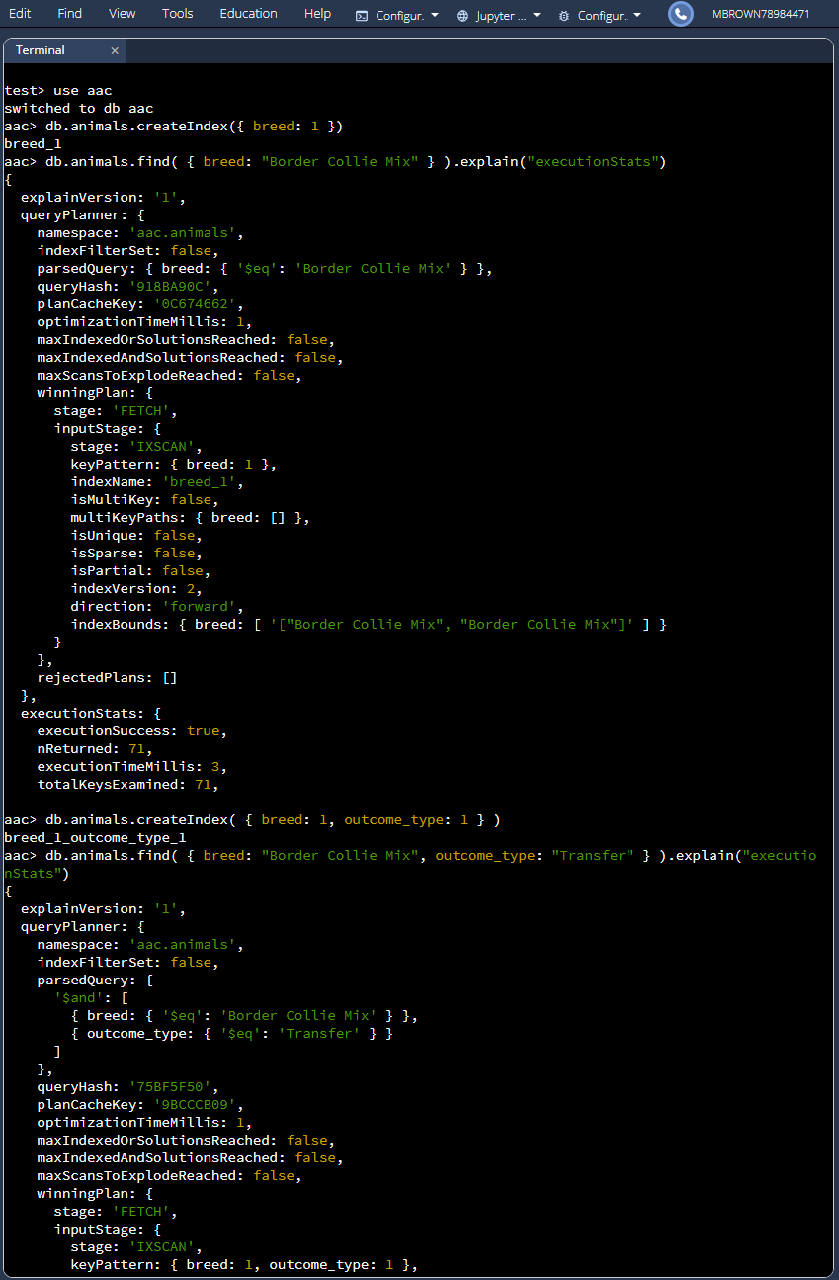
Part II: User Authentication
Create a new user account called “aacuser” & Login Process
